Test Case 1

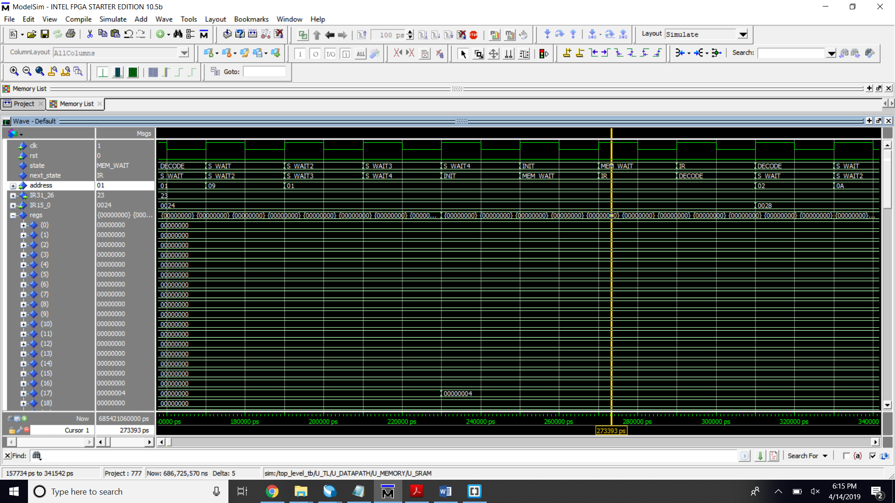  
Image 1. lw $s1, 0x9($Zero) - load word in address 0x9 + zero to s1

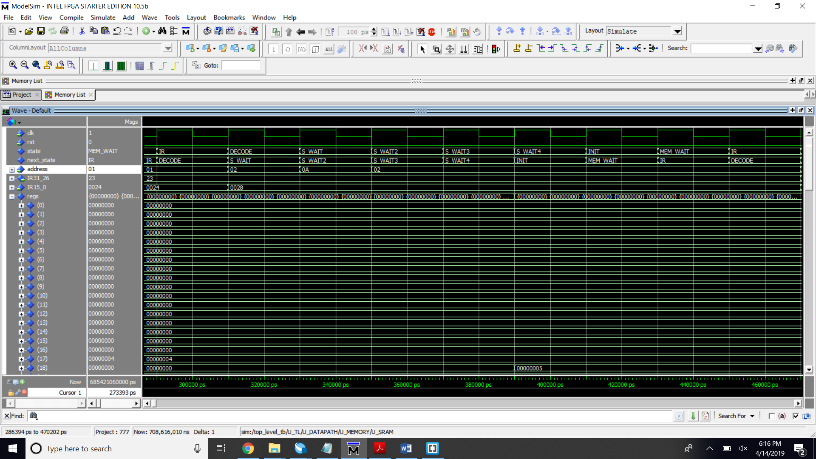

Image 2. lw $s2, 0xA($zero) - load word in address 0xA

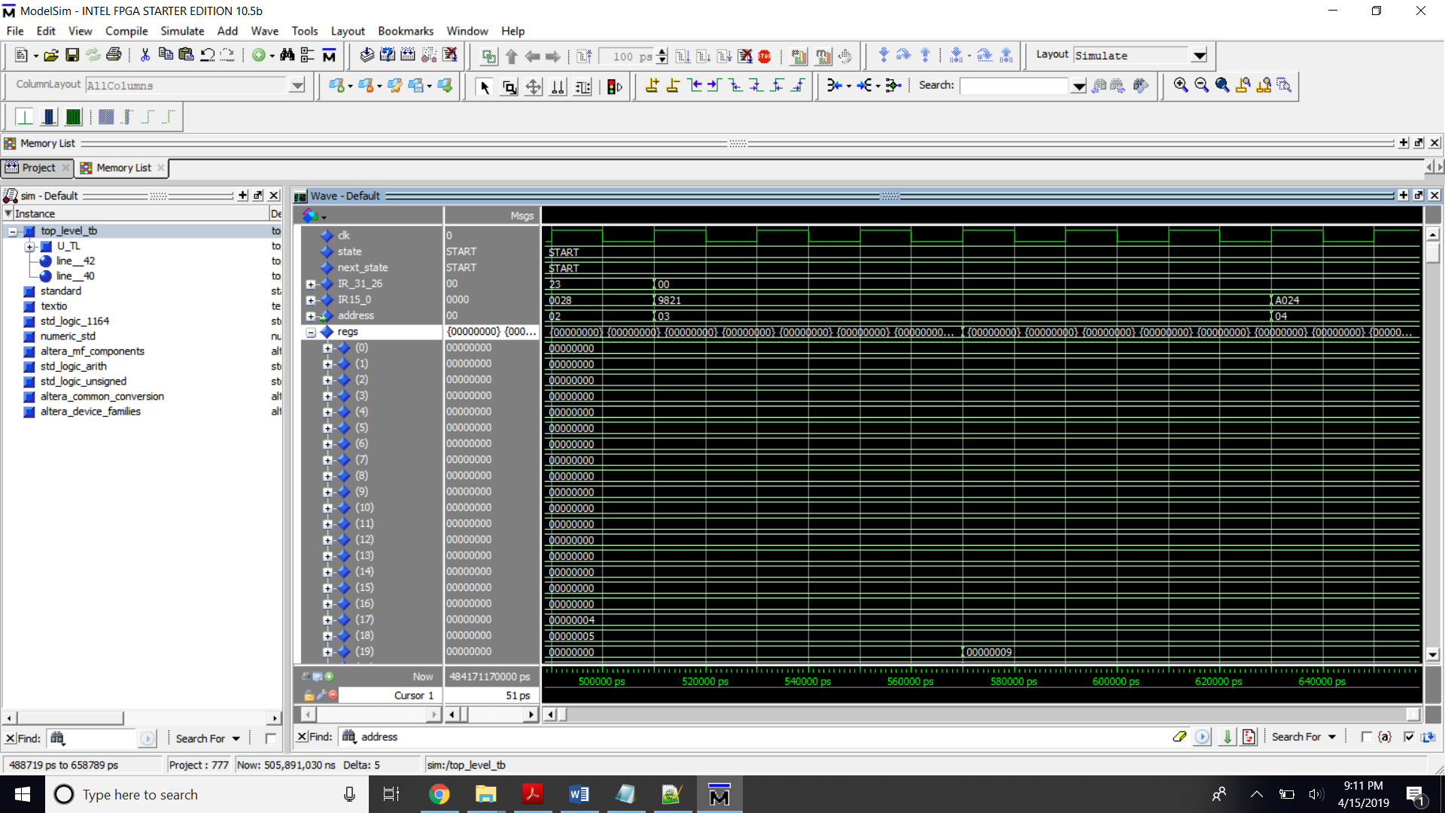

Image 3. addu $s3, $s1, $s2 – add s1 and s2

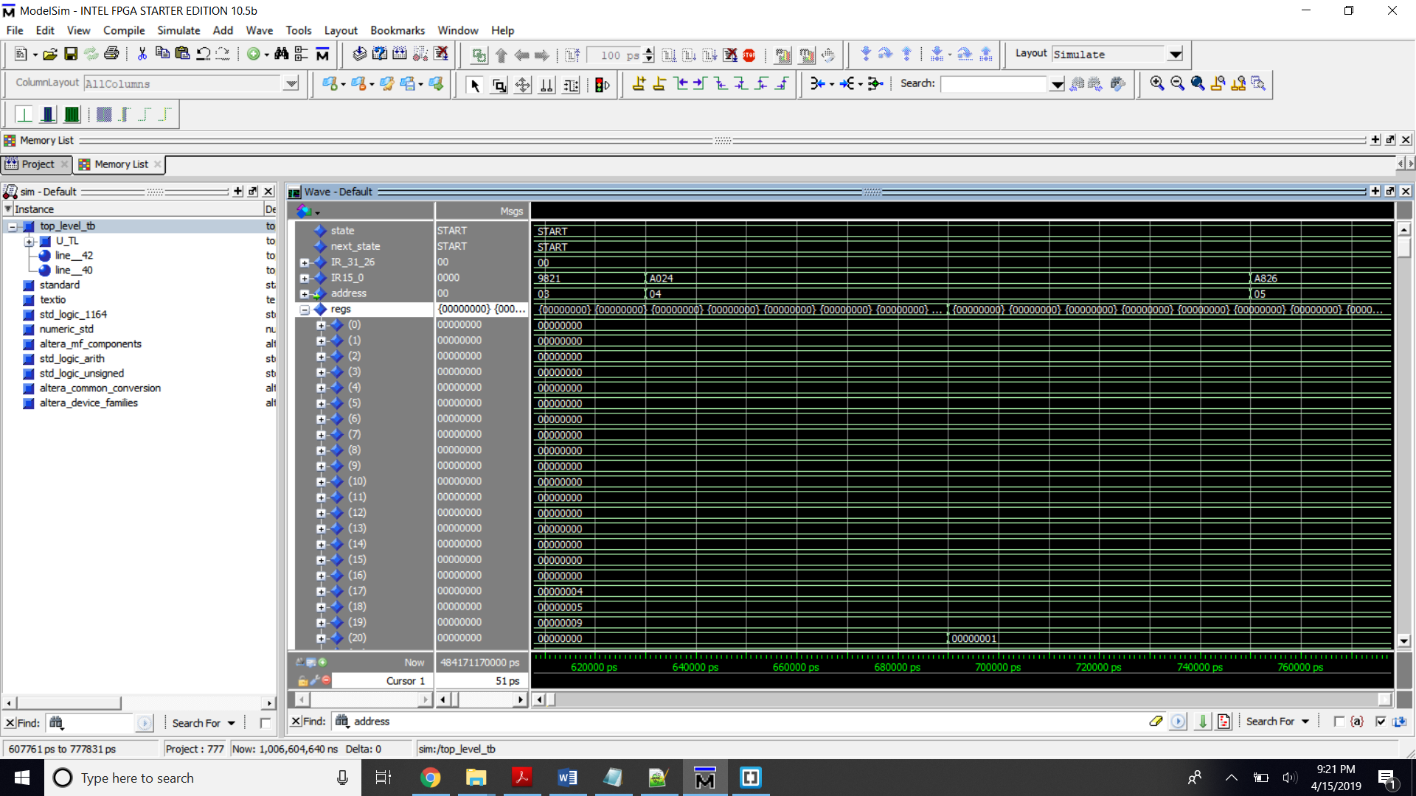

Image 4. and $s4, $s2, $s3 – and s3 and s2

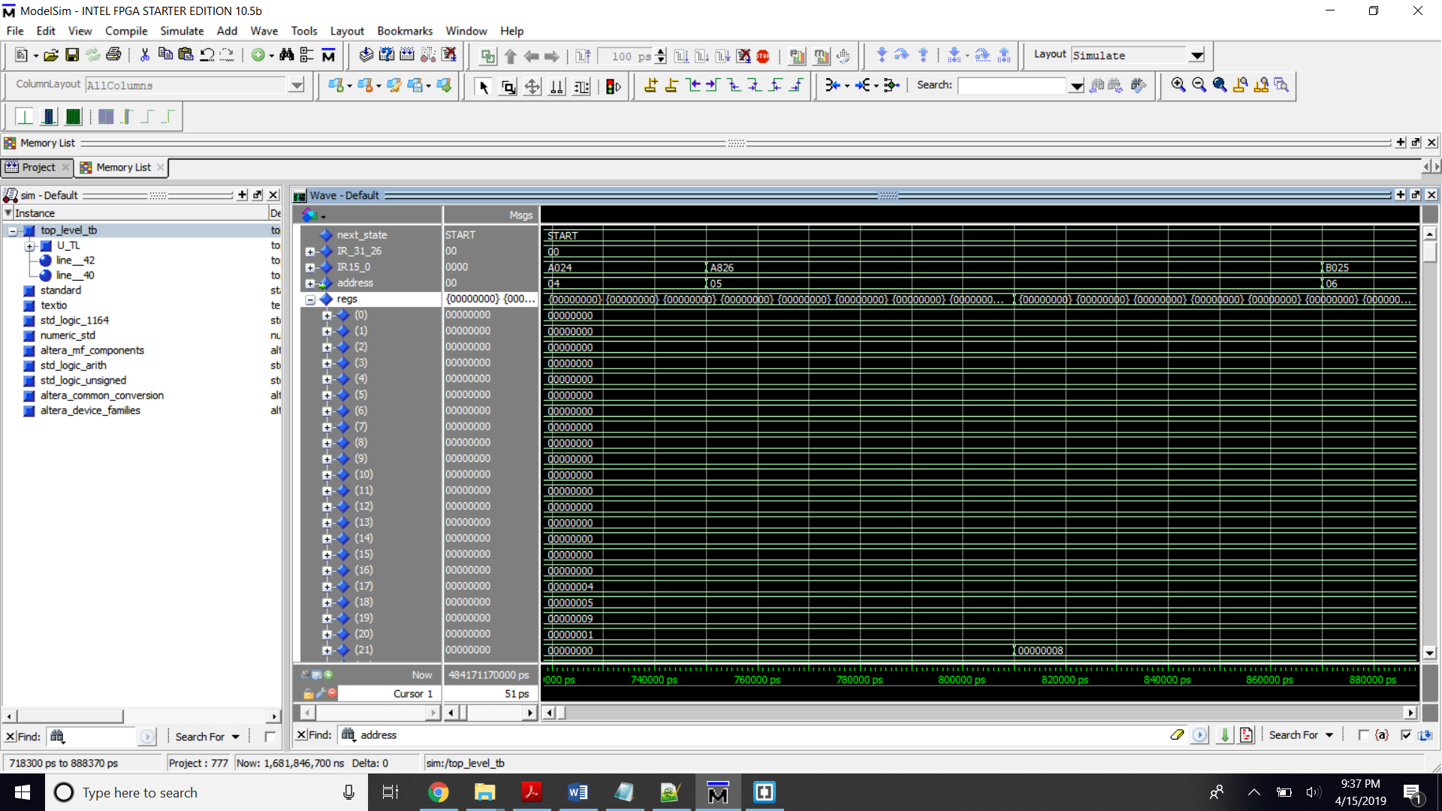

Image 5. Xor $s5, $s3, $s4

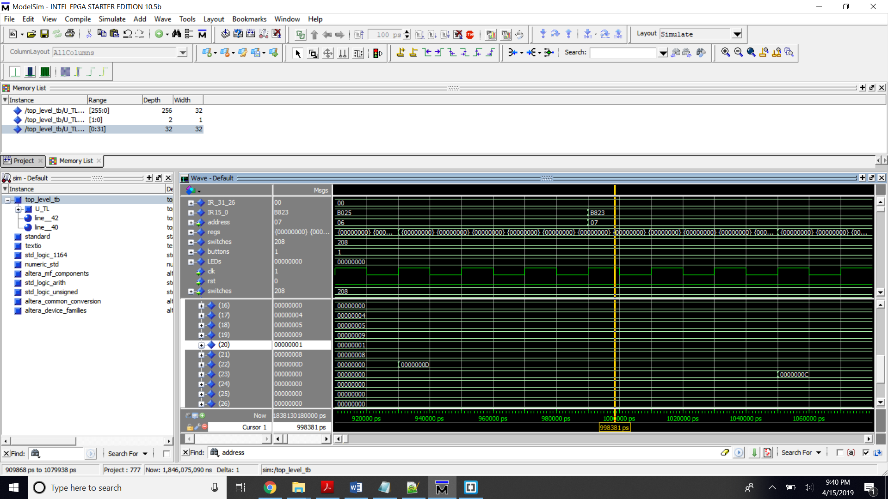

Image 6. (or $s6, $s3, $s1) , (sub $s7, $s6, $s4)

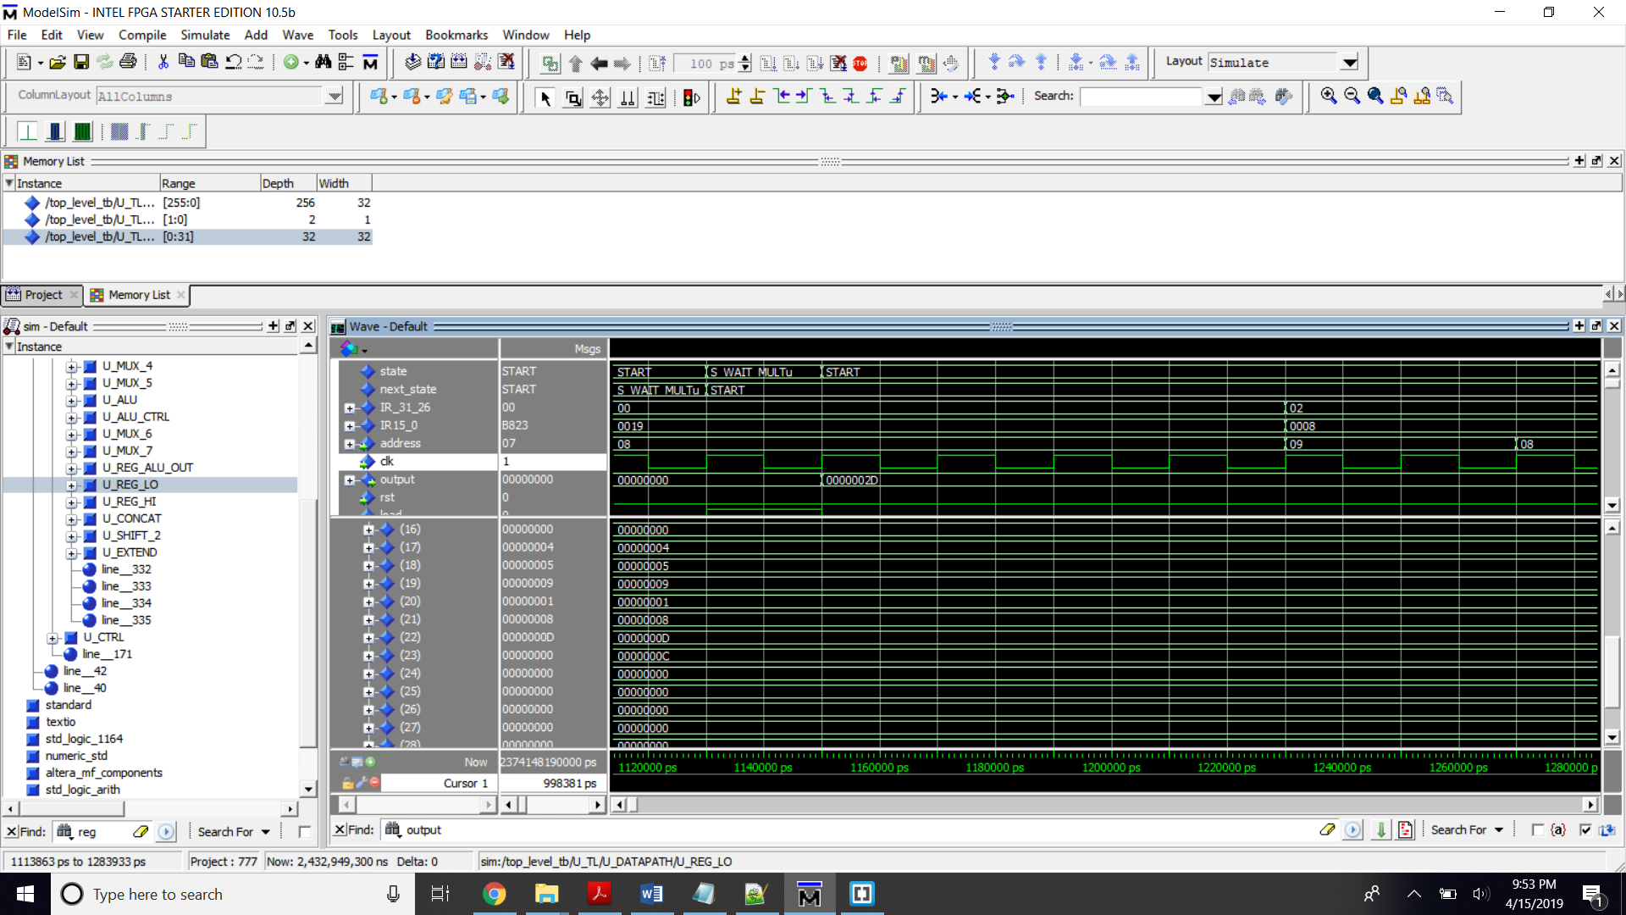  
Image 7. multu $s3, $s2, LO = 2D

Test Case 2

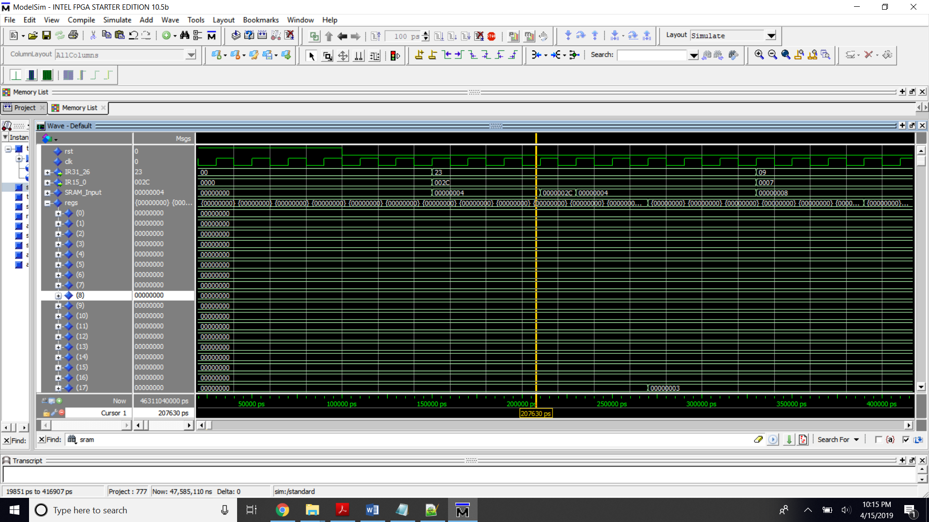  
Image 8. lw $s1, 0B($zero), load word in adress 0B + 0 to s1, s1/r17 = 3

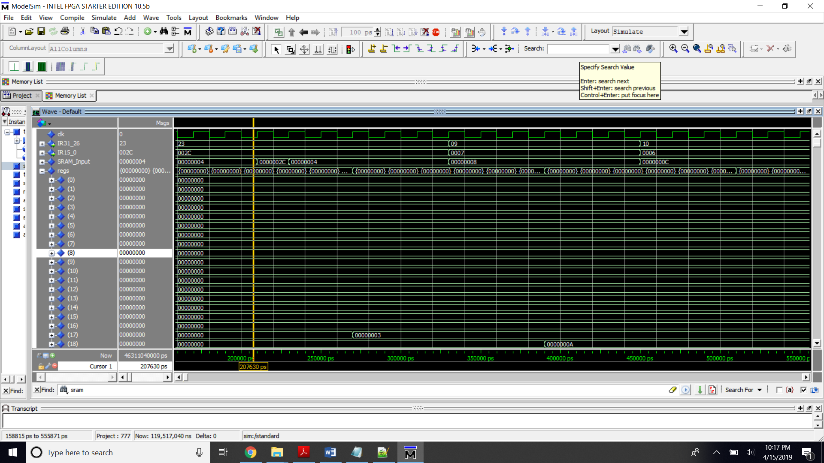  
Image 9. addiu $s2, $s1, 7, add immediate s2 = s1 + 7, s2/r18 = A

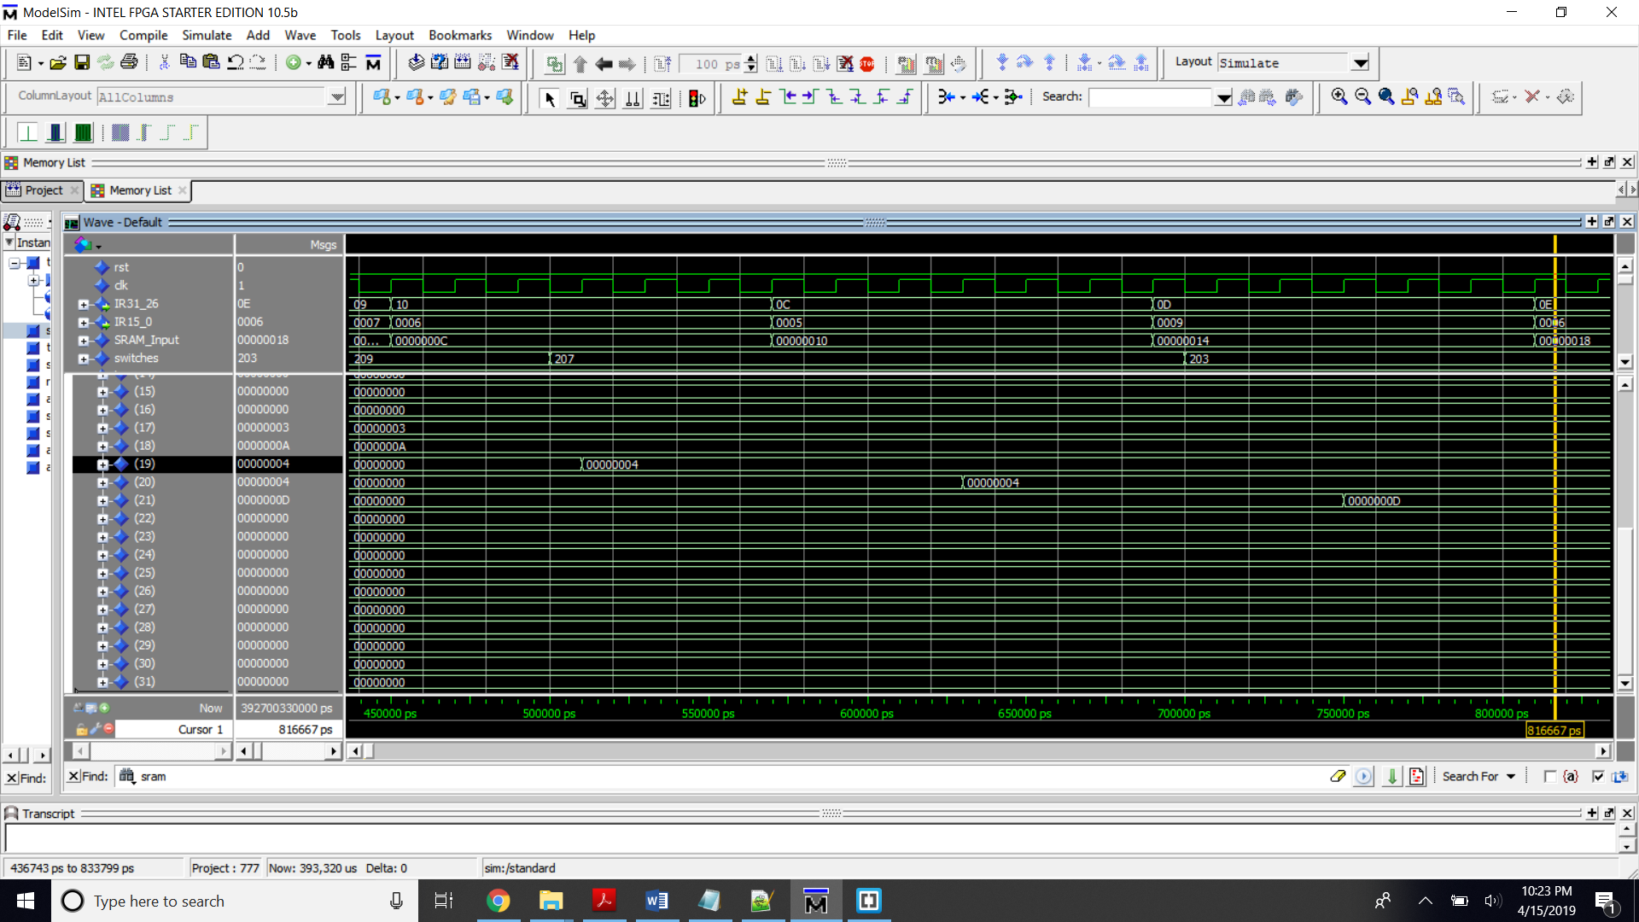

Image 10. -- subiu $s3, $s2, 6,/ sub immediate s3 = s2 – 6,/ s3/r19 = 4  
andi $s4, $s3, 5,/ and immediate s4 = s3 and 5, // s4/r20 = 4  
ori $s5, $s4, 9,/ or immediate s5 = s4 or 9, // s5/r21 = D

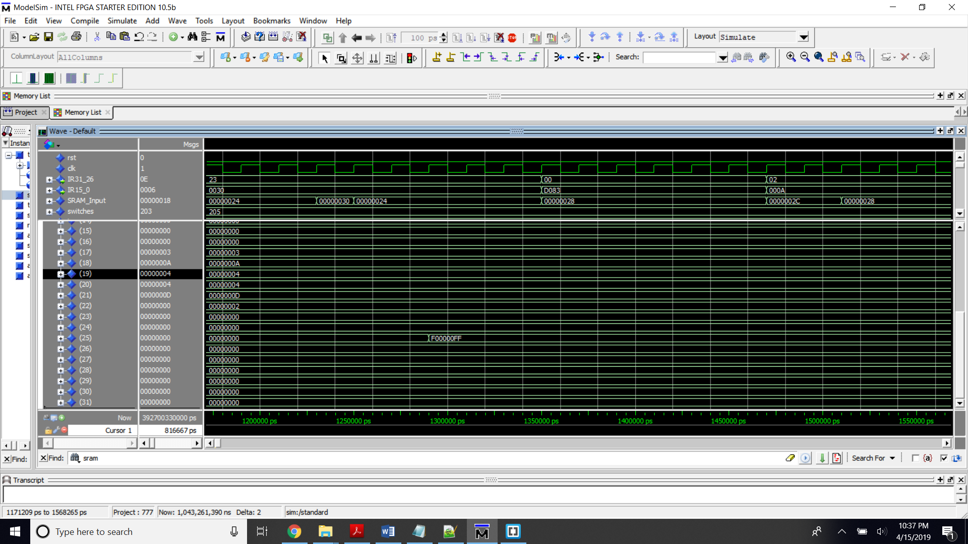  
Image 10. lw $s9, 0C($zero), load word in address 0C + zero to s9, s9/r25 = F00000FF

Test Case 4

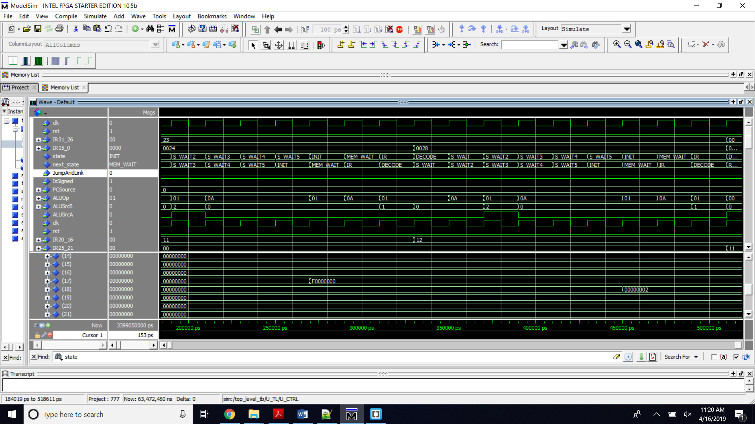  
Image 11. lw $s1, 09($zero) / load word in address 09 + 0 to s1 // s1/r17 = F0000000  
lw $s2, 0A($zero) / load data in address 28 + 0 to s2 // s2/r18 = 00000002

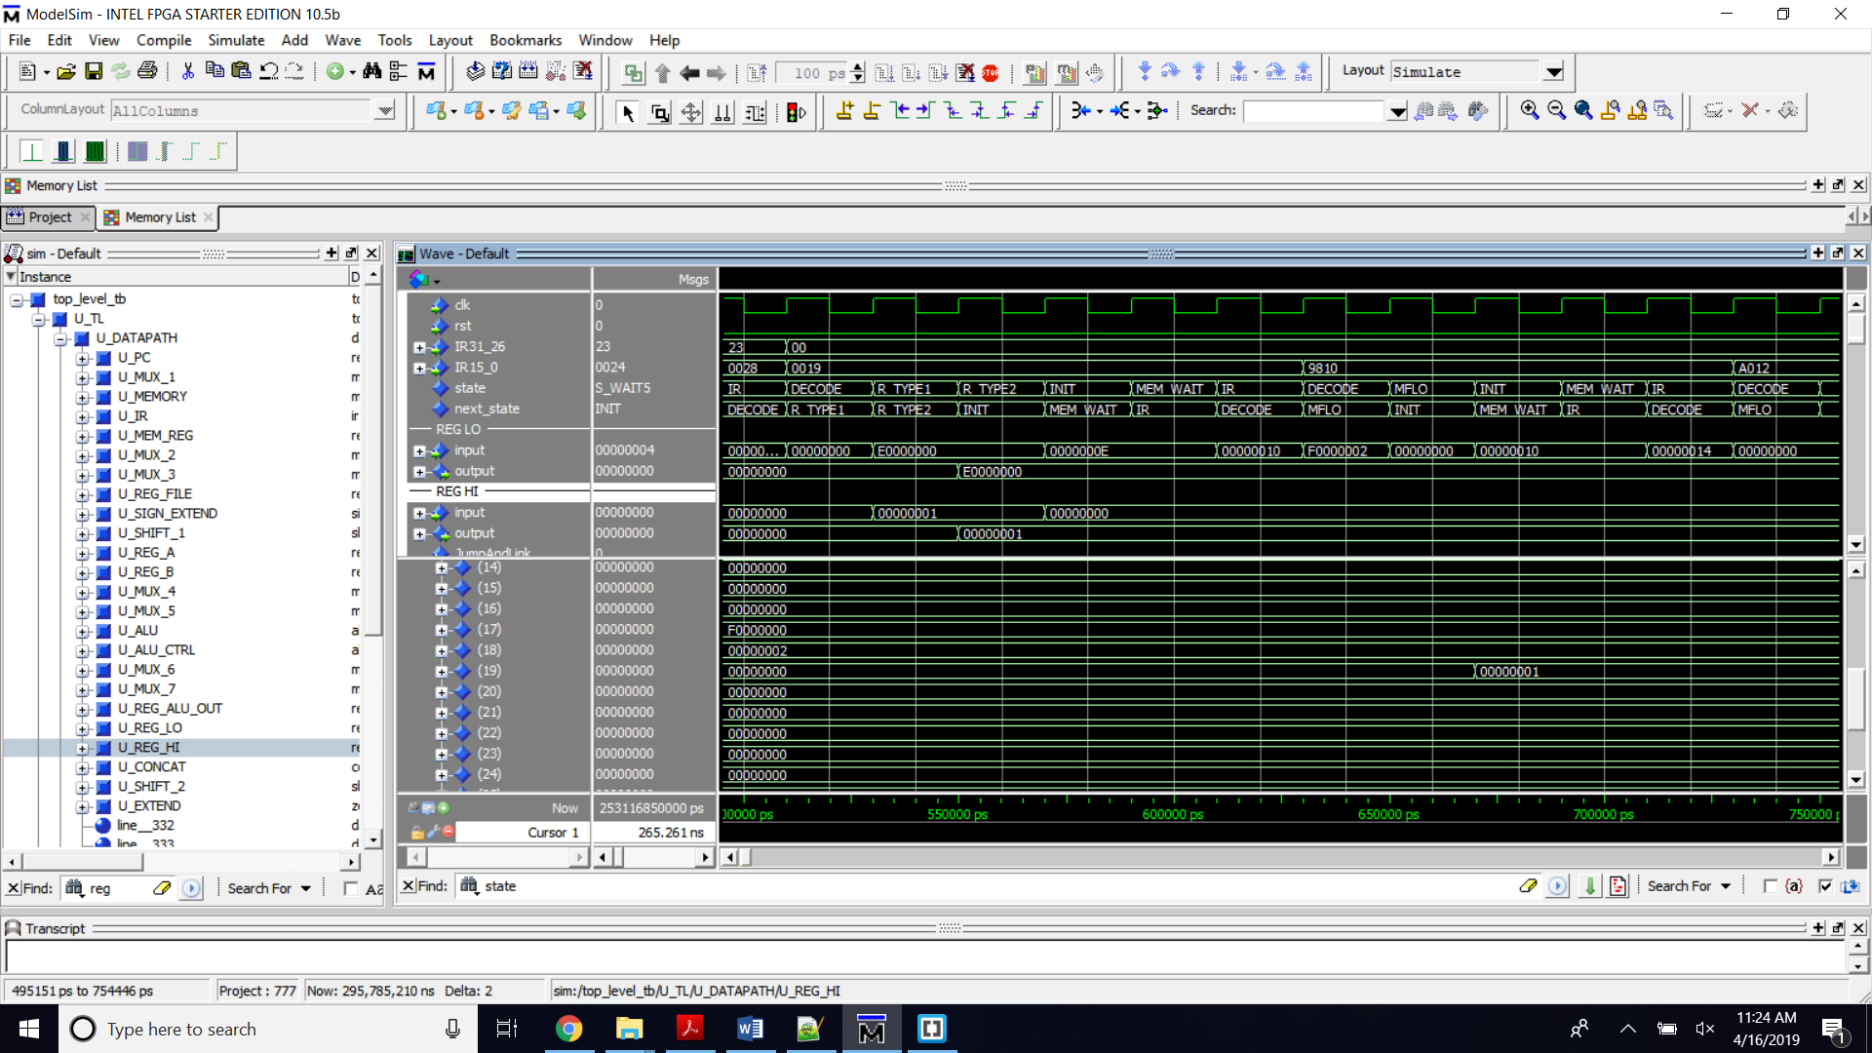  
Image 12. multu $s1, $s2 / mult unsigned s1 \* s2 // HI= 1 ,LO= E00000000  
-- mfhi $s3 / move from HI to s3 // s3/r19 = 1

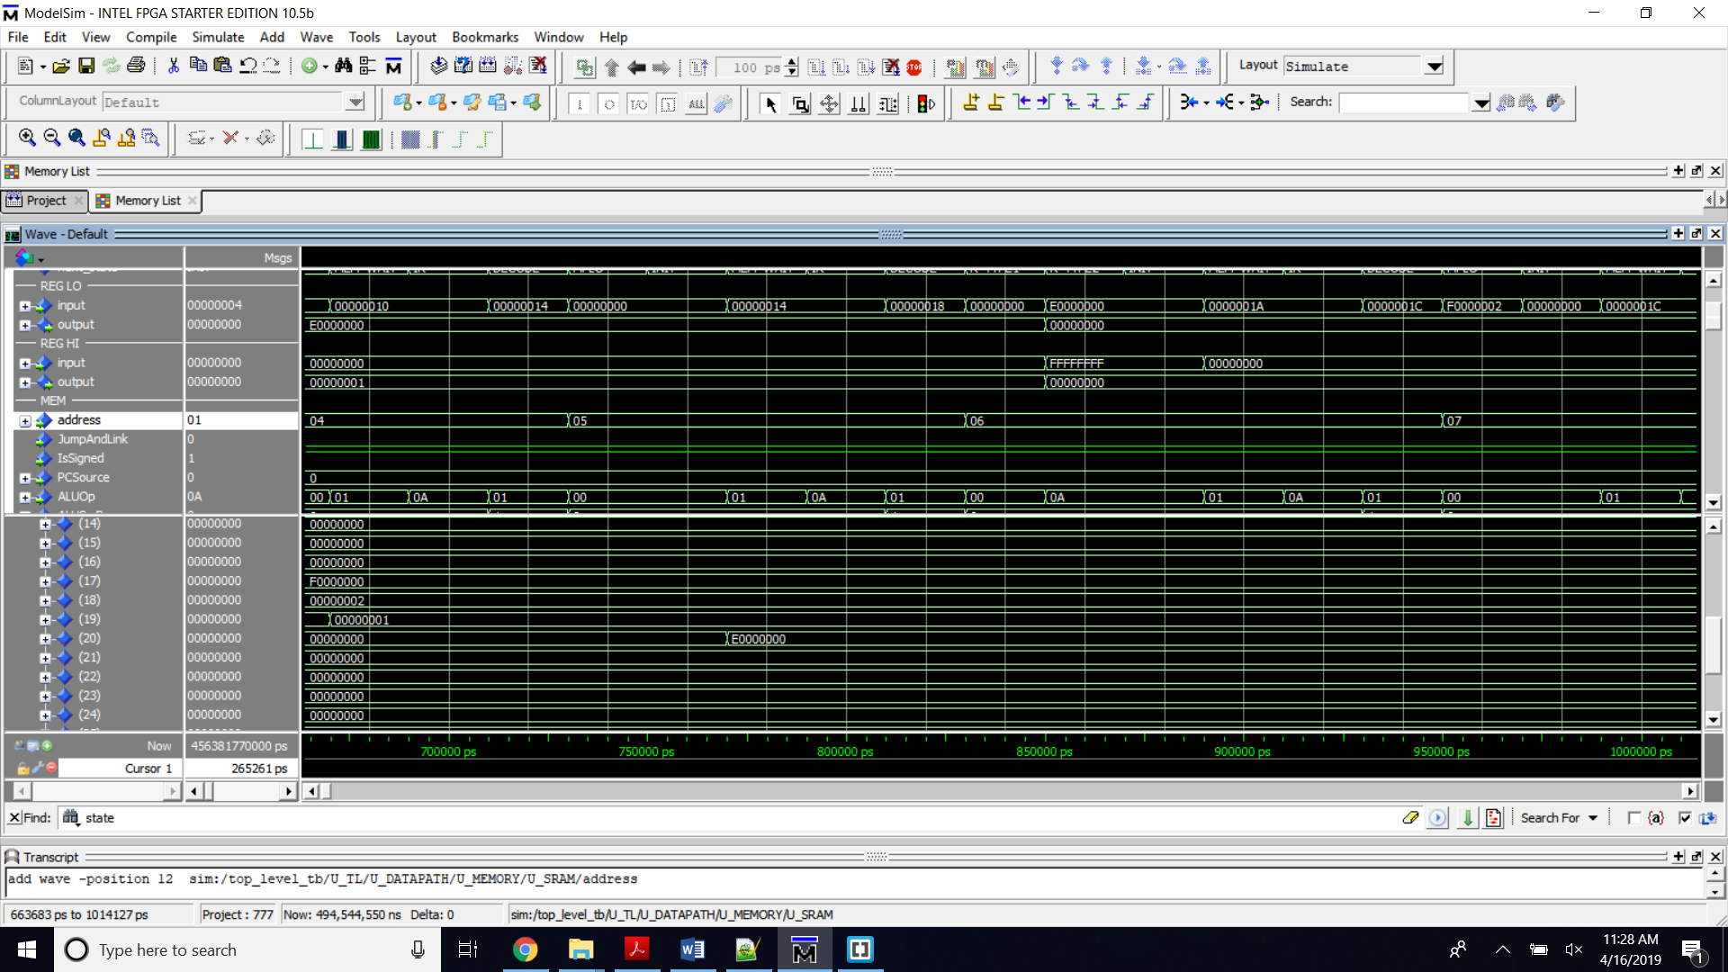  
Image 13. -- mflo $s4 / move from LO to s4 // s4/r20 =E00000000

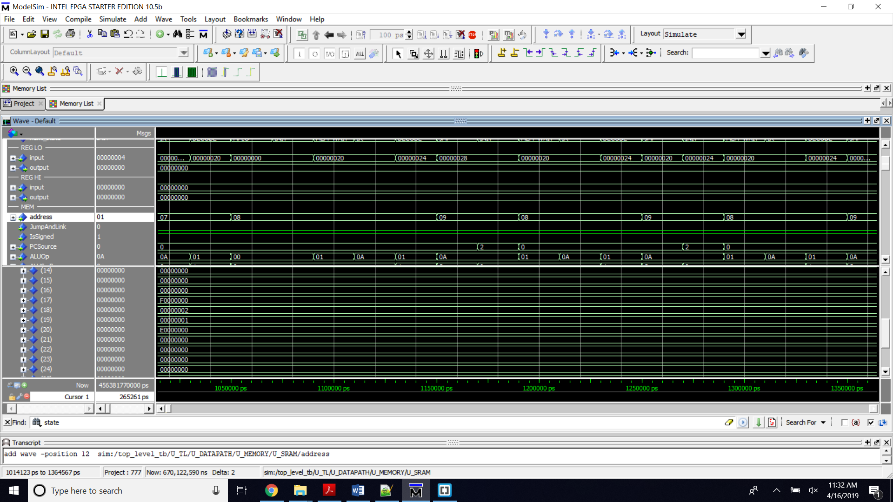Image 14. j 8 / infinite loop

Test Case 7

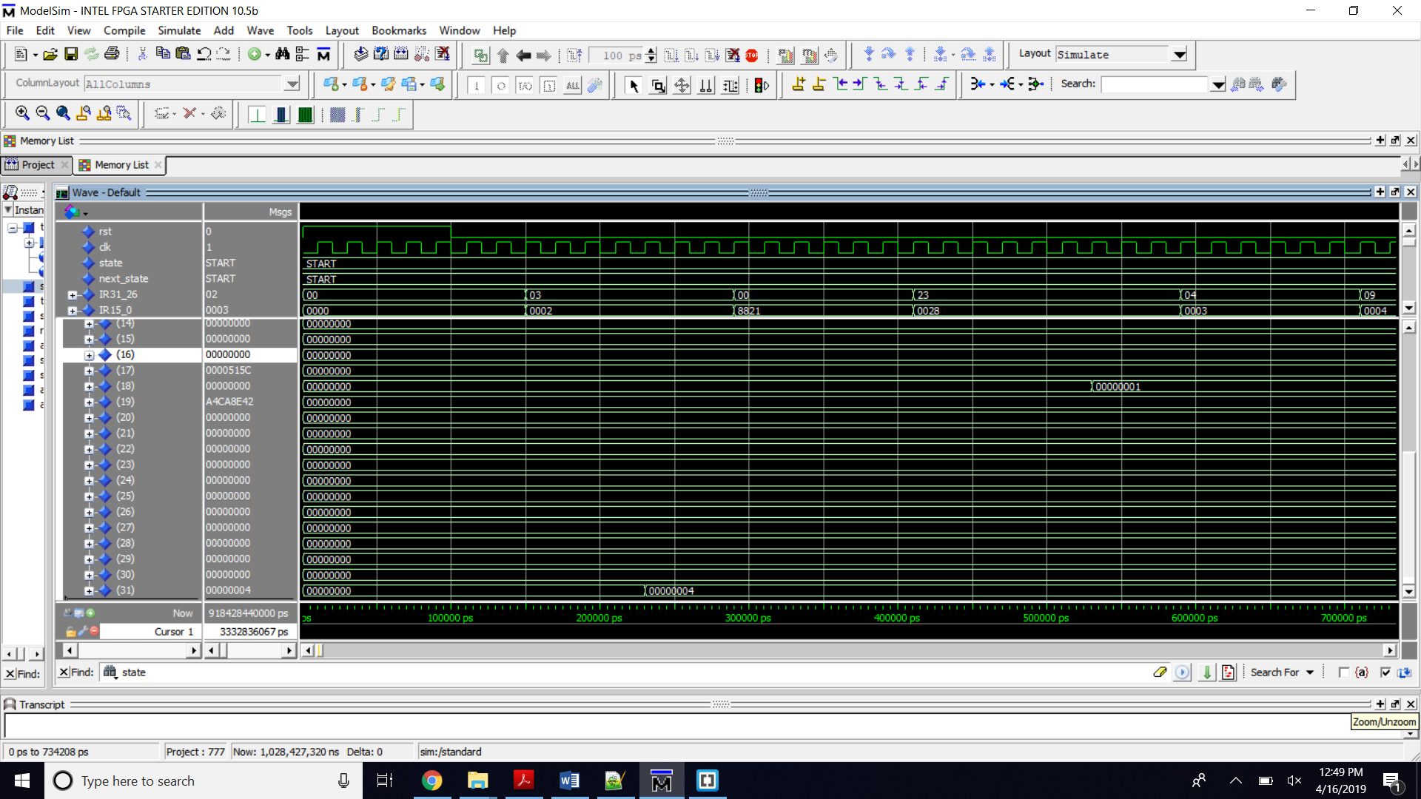  
Image 15. jal 2 / jump to address 2 and $ra= PC + 4  
-- j 1 / infinite loop  
-- addu $s1, $zero, $zero / $s1 = 0;

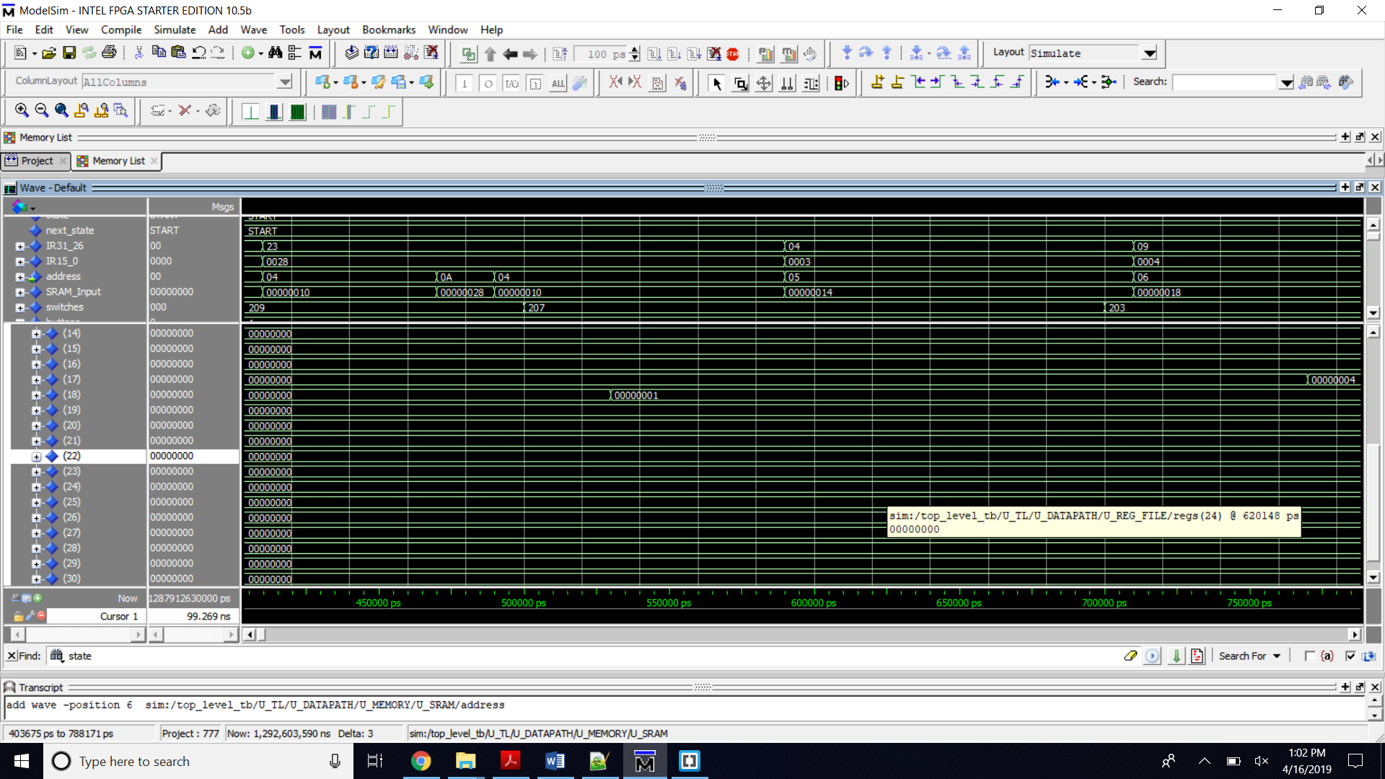  
Image 16. lw $s2, 0A($s1) / load word in adress 0A + s1 to s2

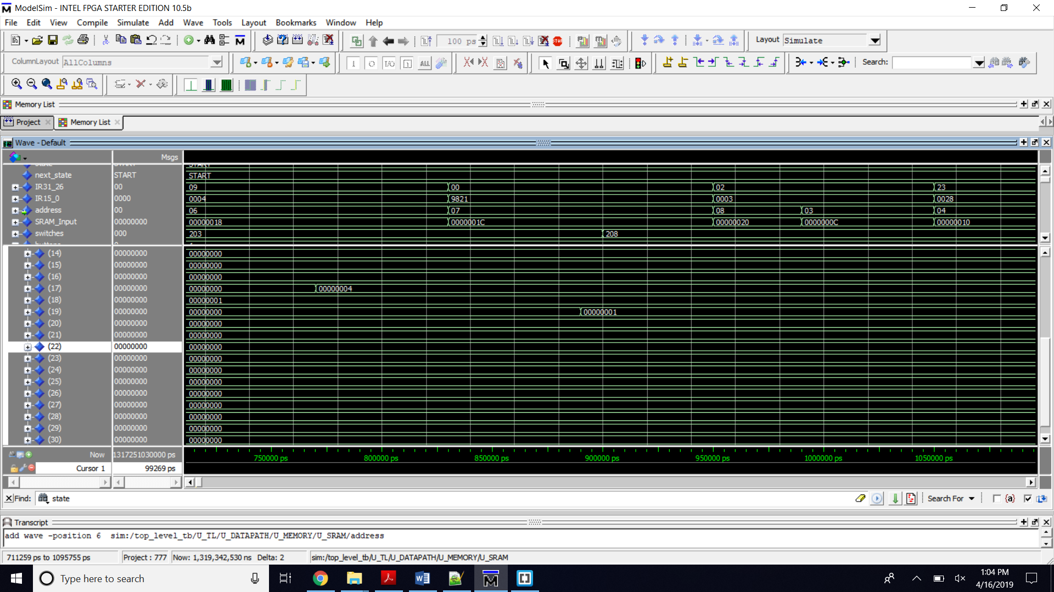

Image 17. addiu $s1, $s1, 4 / calculate the new address s1 = s1 + 4  
addu $s3, $s3, $s2 / add the number to the accumulator s3 = s3 + s2

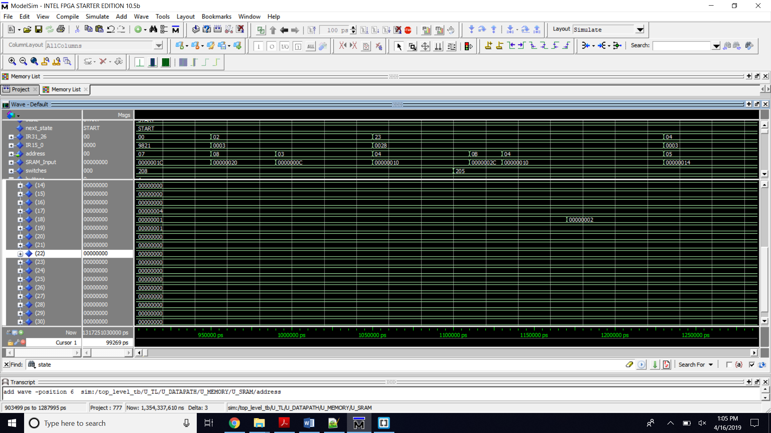Image 18. j3 / Jump to address 3

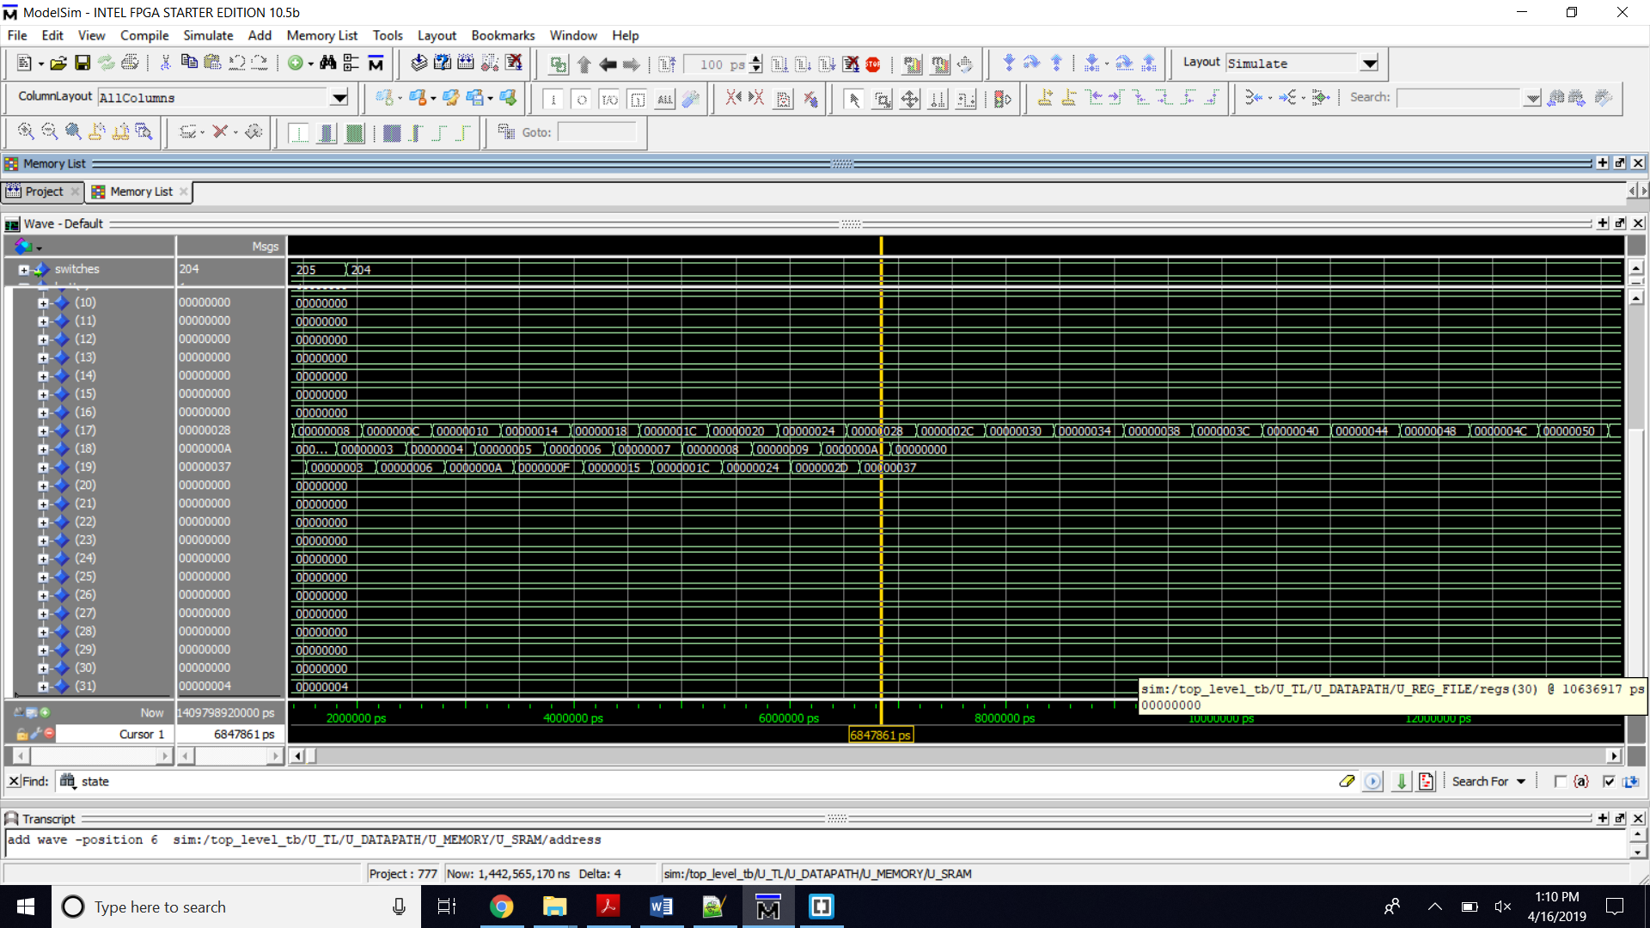  
Image 19. sw $s3, FFFC($zero) / store s3 to the outport1  
jr $ra / PC= $ra // PC = 4

Bubble sort

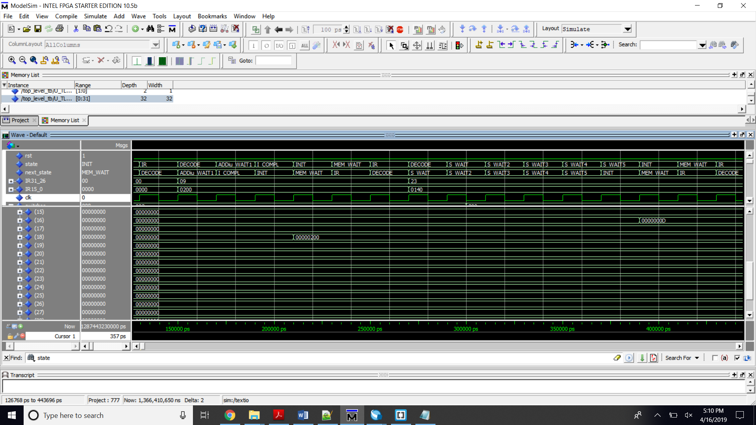  
Image 20.  
addiu $s2, $zero, address // load the table address to S2/R18  
--lw $s0, 50($zero) // load the size of the table from Inport0 to S0/R16

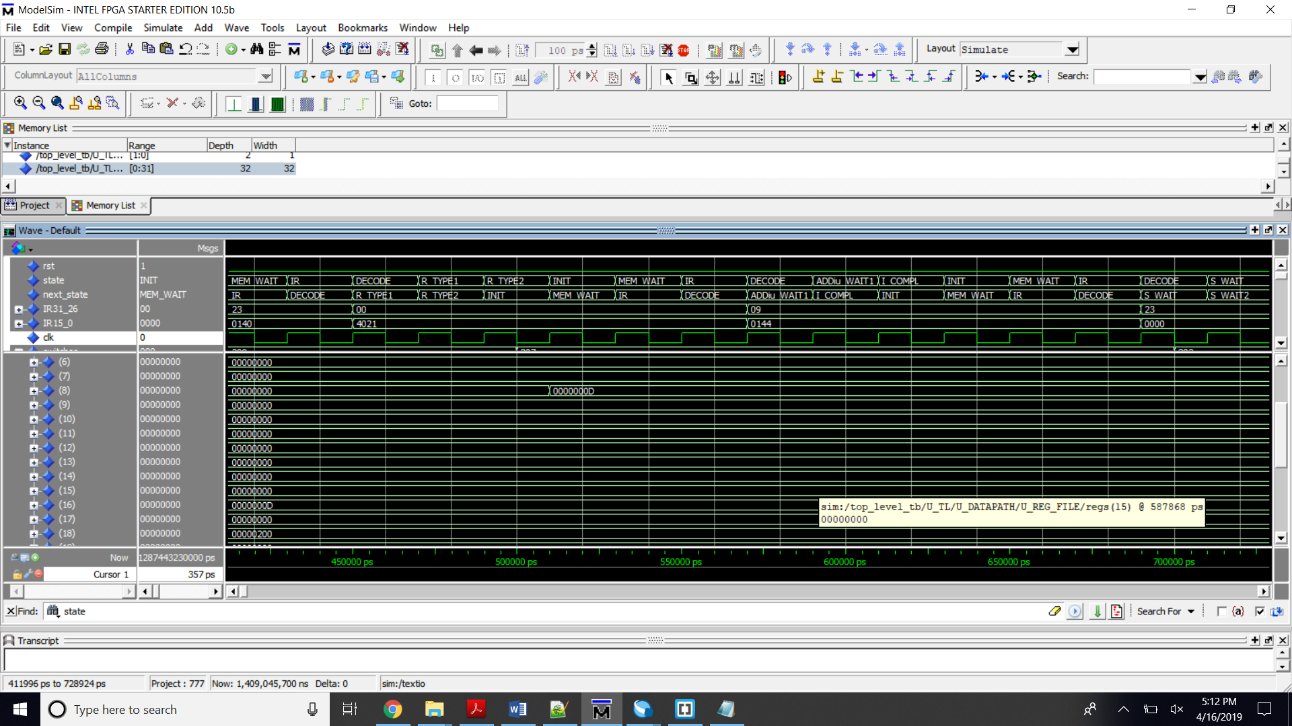  
Image 21. add $t0, $s0, $zero // copy the size of the table to t0/R8, will be used as a counter

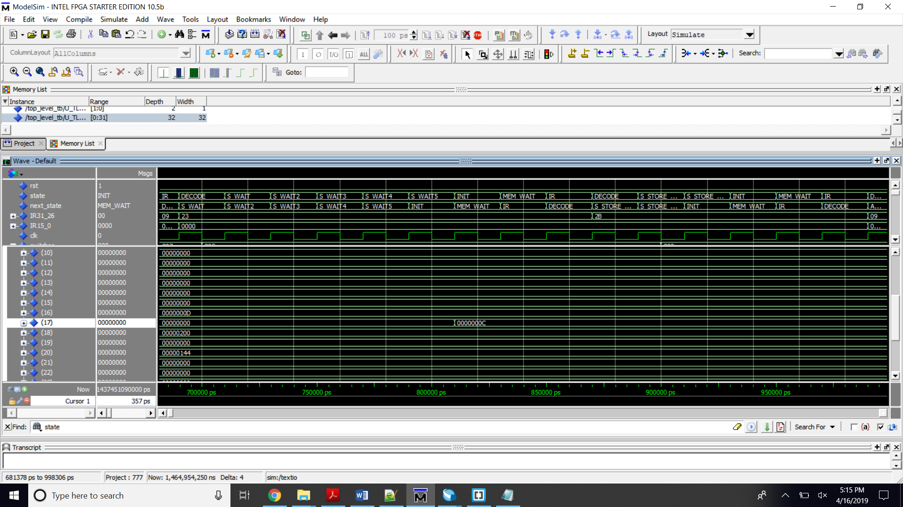  
Image 22. --lw $s1, 0($s4)// load the first entry of the table from Inport1 to S1/R17

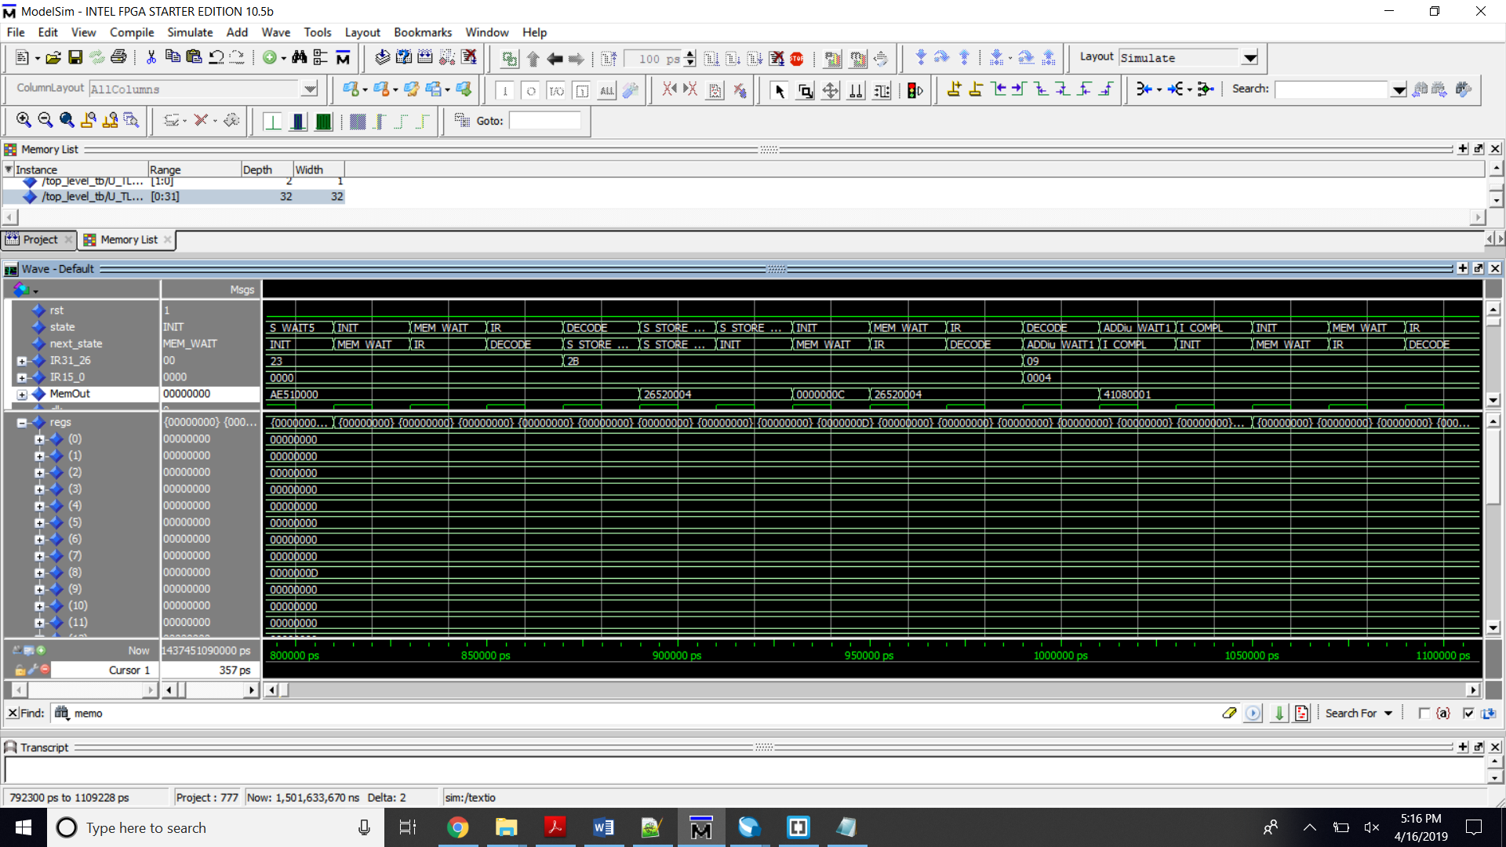  
Image 23. -sw $s1, 0($s2) // store S1/R17 in the address pointed by S2/R18

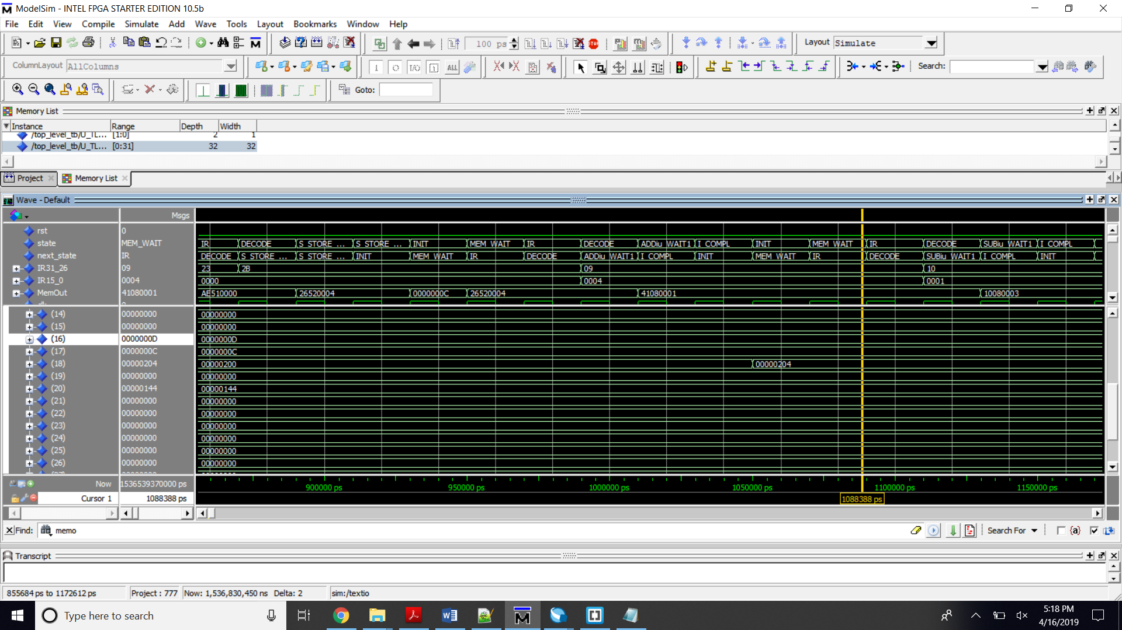  
Image 24. --addui $S2, $s2, 4 // increment address

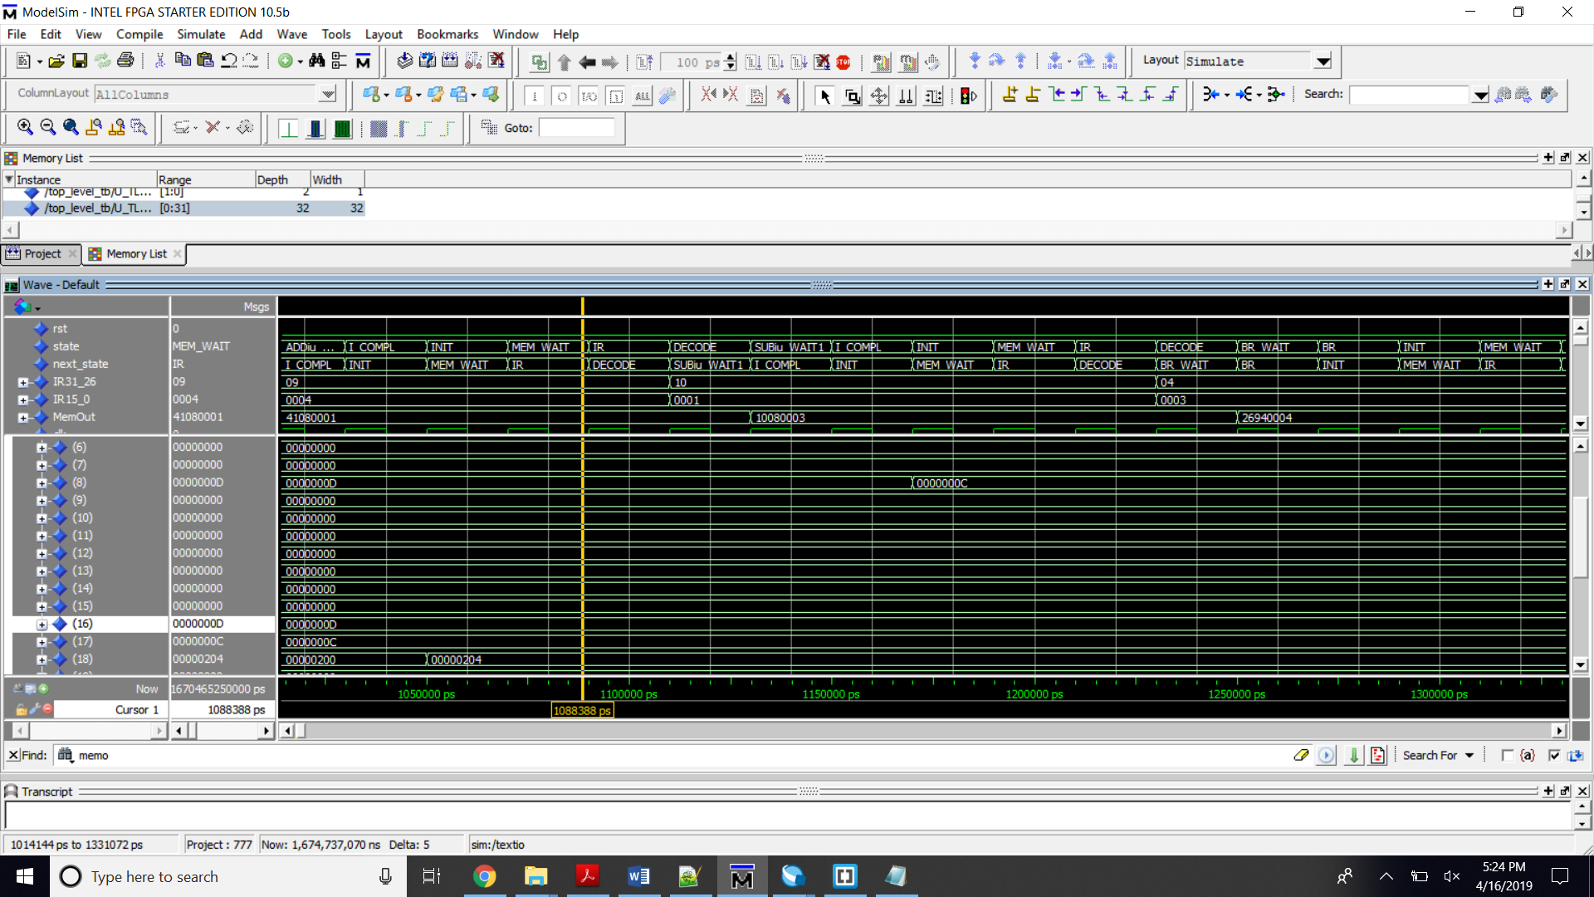  
--subiu $t0, $t0, 1 // decrement the counter

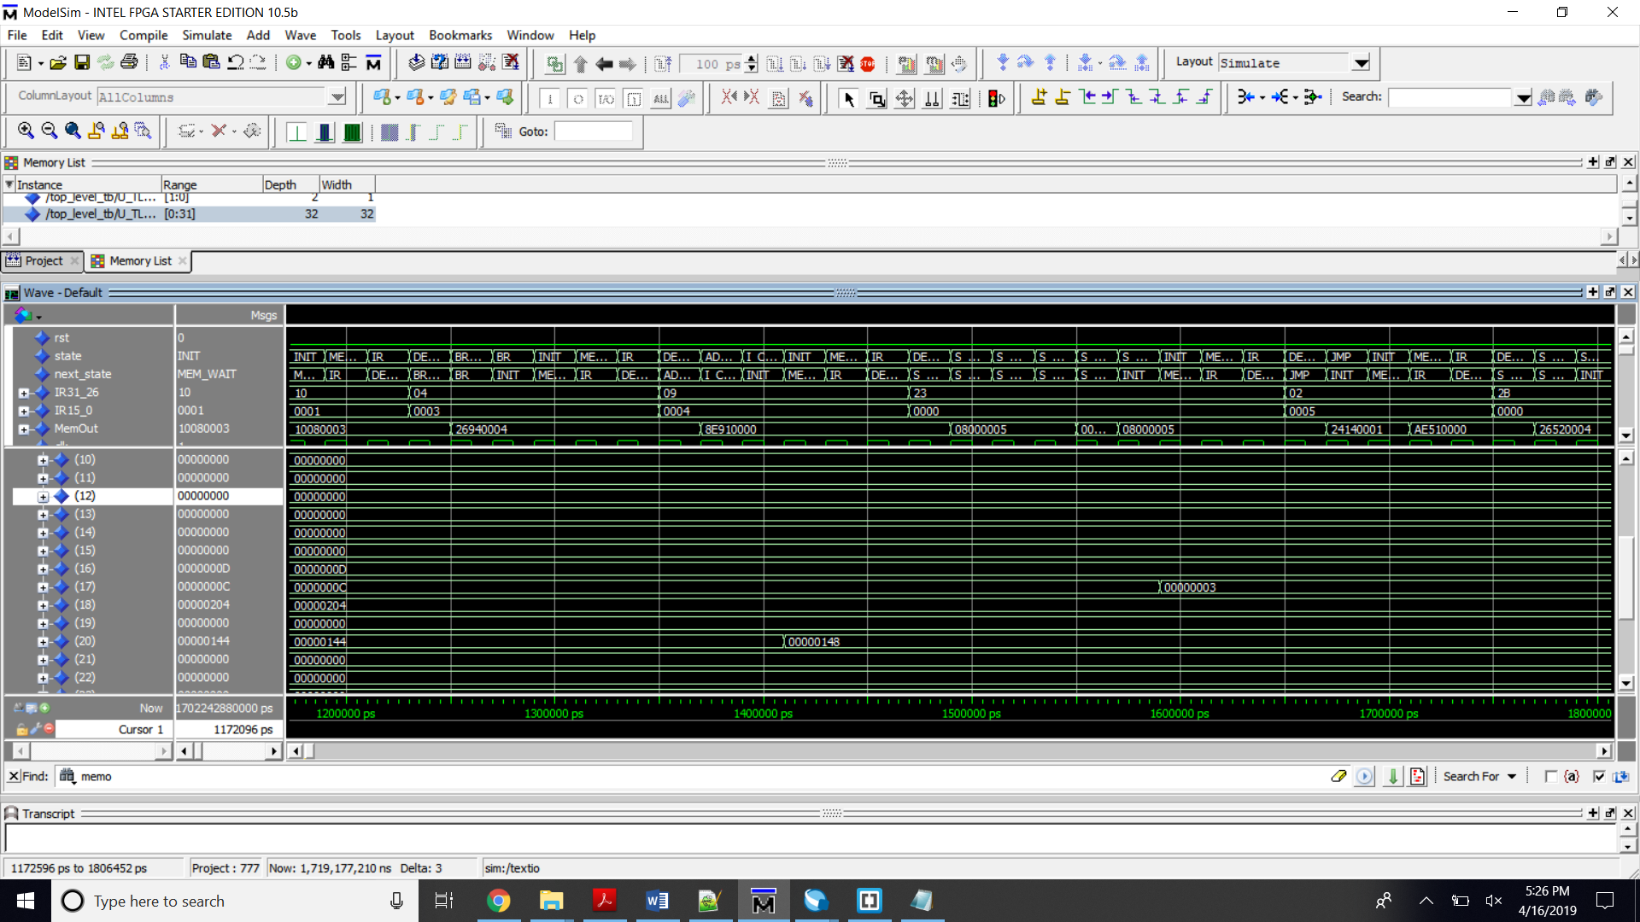

--addui $s4, $s4, 4 // increment pointer

--lw $s1, 0($s4) // load the next entry  
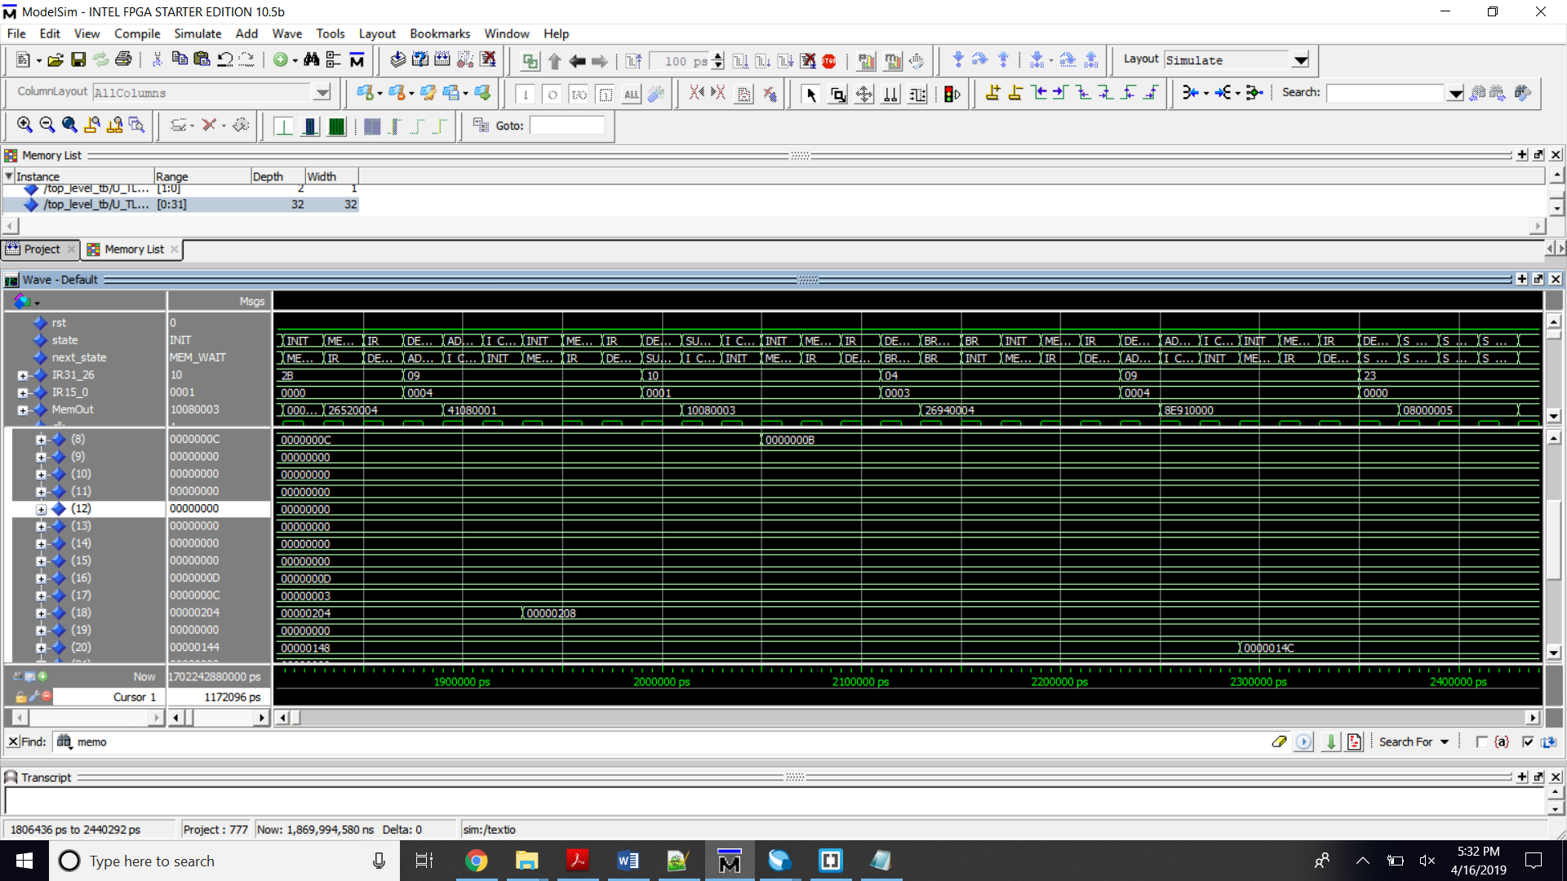

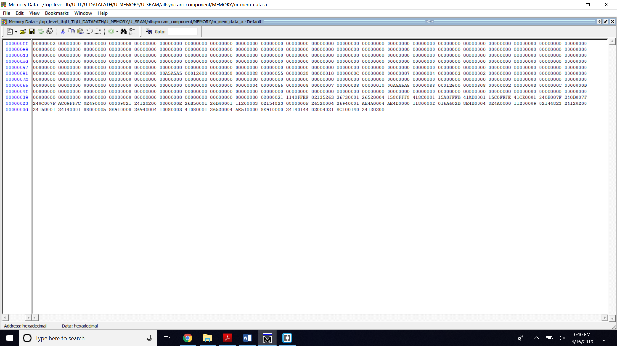  
Final Result

GCD

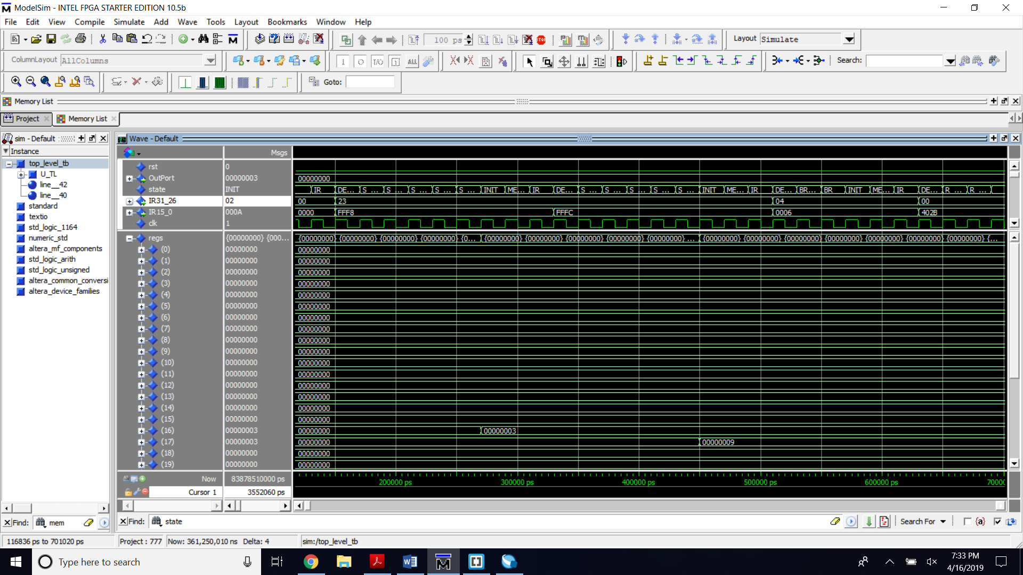  
-- W lw $s0, FFF8($zero) // Load word from the InPort0 to $S0/R16  
-- W lw $s1, FFFC($zero) // Load word from the InPort1 to $S1/R17

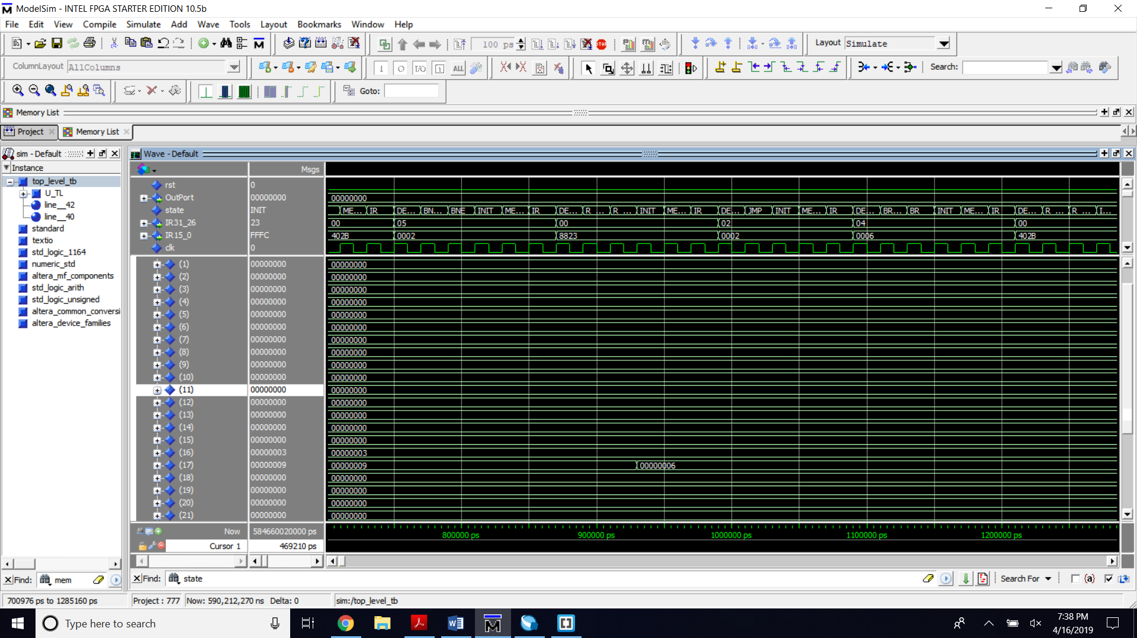

-- W subu $s1, $s1, $s0 // $s1= $s1- $s0

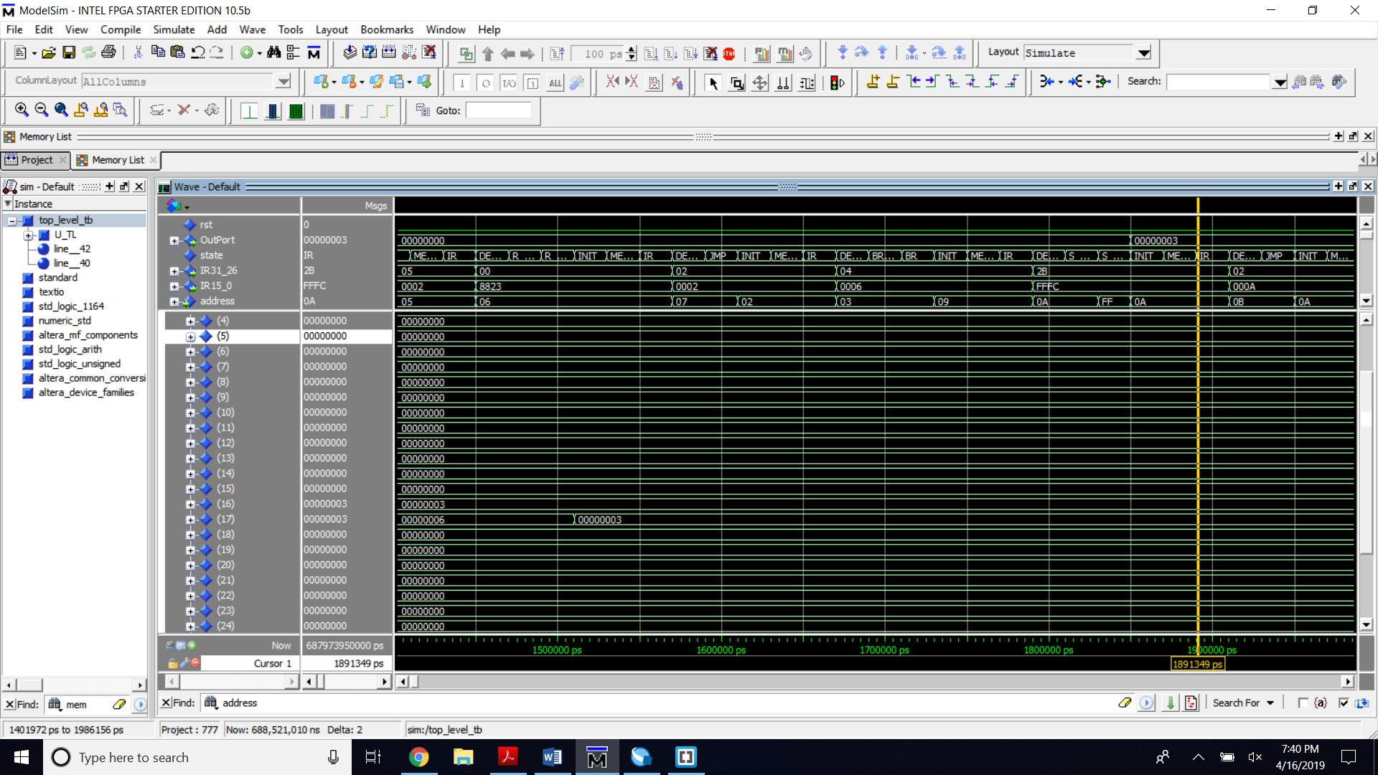  
-- W subu $s1, $s1, $s0 // $s1= $s1- $s0  
W exit the loop //sw $s0, FFFC($zero) // store s1 to the outport1